Contents
1.0 User Story 2
2.0 Wireframe & UI Requirements 3
Wireframe 1: Recurring Payments Scheduled 3
Wireframe 2: ‘Are you Sure?’ Pop-Up 4
Wireframe 3: Recurring Payments Cancelled 5

1.0 User Story
Title: Delete Recurring Payment
As a: | Group Insurance Administrator
I want to: | Have an ability to delete a scheduled recurring payment
So that: | I can have the self-service capability of cancelling a recurring payment and do not have to place a cancellation request via mail or fax.
Acceptance Criteria: | - On the ‘Recurring Payments Scheduled’ page, system shall display an option to ‘Cancel Payment’ {refer to wireframe 1:Recurring Payments Scheduled}  - On selecting the ‘Cancel payment’ command button, system shall display the “Are you Sure?” pop-up window {refer to wireframe 2: Are you Sure?}  - On selecting the ‘No’ command button, system shall close ‘Are You Sure’ pop-up.  - On selecting ‘Yes’ command button, system shall do the following:  - Cancel the recurring payment scheduled request and navigate the user to ‘Recurring Payment Cancelled’ page. {refer to wireframe 3:Recurring Payments Cancelled}  - Send out an email to the contact email on file with the following details:  From Email: donotreply@libertyinsurance.com  Subject: Scheduled Recurring Payment Cancellation Notification  Email Text:  Dear <Contact Name>  The following scheduled recurring payment has been successfully cancelled:  Cancellation Date: <Date>  Group Premium Amount: <Total Due>  Pay From: <Pay from Bank Name & Acc #>  Scheduled For: <’Scheduled For’ Day of month since>

2.0 Wireframe & UI Requirements

Wireframe 1: Recurring Payments Scheduled
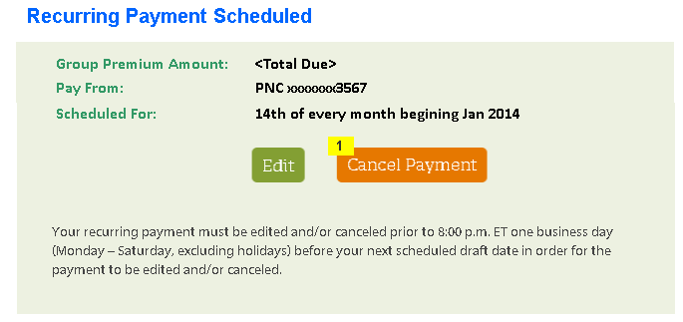
ID | Field Name | Field Type | Notes
1 | Cancel Payment | Command Button | On click, launch ‘Are You Sure’ pop-up

Wireframe 2: ‘Are you Sure?’ Pop-Up
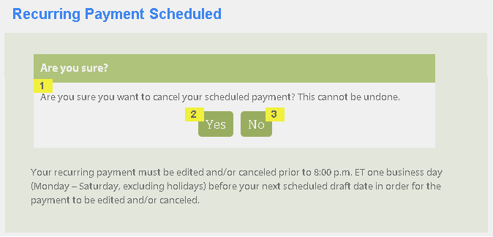
ID | Field Name | Field Type | Notes
1 | Are you sure you want to cancel your scheduled payment? This cannot be undone | Read Only Text
2 | Yes | Command Button | On click, close the pop-up and navigate the user to ‘Recurring Payment Cancelled’ page
3 | No | Command Button | On click, close the pop-up and remain on ‘Recurring Payment Scheduled’ page

Wireframe 3: Recurring Payments Cancelled
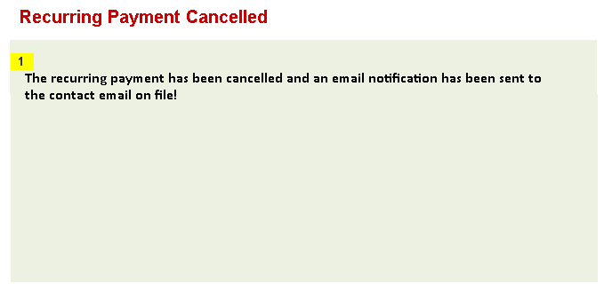
ID | Field Name | Field Type | Notes
1 | The recurring payment has been cancelled and an email notification has been sent to the contact email on file! | Read Only Text

